**S.1 CHEMISTRY END OF TERM II EXAMINATION 2023**

**DURATION: 2 hours**

**NAME .....................................................................................................STREAM........................**

***INSTRUCTIONS***

* *This paper consists of two sections* ***A*** *and* ***B****, which are all* ***compulsory.***
* *Answers to* ***section B*** *are to be written on the* ***answer sheets*** *provided and tied together.*
* ***Number your work very well*** *on the* ***answer sheets*** *provided.*

|  |  |  |
| --- | --- | --- |
| ***FOR EXAMINERS USE ONLY*** | | ***TOTAL*** |
| ***SECTION A*** |  |  |
| ***SECTION B*** |  |

**SECTION A (50MARKS)**

1. Chemistry is the study of matter and the changes that occur to substances under different conditions. It is one of the **most important subjects** taught at Secondary level of education. When you study chemistry, you not only acquire knowledge about many chemical reactions and other substances, but also you can take up various careers after your studies.
2. Mention **four** reasons as to why you need to study chemistry subject. ***(04marks)***

....................................................................................................................................................................................................................................................................................................................................................................................................................................................................................................................................................................................................................................................................................................................................................................................................................................................................................................................................

1. What are some of the **three possible** **careers/job opportunities** that one can take on after acquiring the knowledge and skills of Chemistry?

..................................................................................................................................................................................................................................................................................................................................................................................................................................................................

***(03marks)***

1. Identify any **four** useful products you know in the environment, which can be made through the knowledge acquired from chemistry.

.......................................................................................................................................................................................................................................................................................................................................................................................................................................................................................................................................................................................................(***03marks)***

2. Mukisa, an S1 student was required to prepare a salt solution in the laboratory. He wrapped his sweater around his waist, picked on his books and ran to the laboratory. On entering, he knocked a table with glassware, spilling a colourless liquid. His books fell down into the pool of the colourless liquid while the glass fell on the floor and broke. Mukisa tried to collect the broken pieces of glass. The pieces cut his fingers while the books were burnt by the liquid. In pain, he rushed to wash his fingers using water and in the process, the sweater around his waist pulled down a beaker of hot water from another table that poured on his leg. Mukisa was rushed to a clinic and never carried out his experiment.

1. From the above passage, what ***errors*** were committed by Mukisa? ***(04marks)***

...................................................................................................................................................................................................................................................................................................................................................................................................................................................................................................................................................................................................................................................................................................................................................................................................................................................................................................................................................................................................................................................................................................................................

1. How could Mukisa have avoided the accident? ***(03marks)***

............................................................................................................................................................................................................................................................................................................................................................................................................................................................................................................................................................................................................................................................................................................................................................................................................

1. Using the above story, what ***rules*** should be enforced to ensure safety in the laboratory?

..........................................................................................................................................................................................................................................................................................................................................................................................................................................................................................................................................................................................................................................................................................................................................................................................(***03marks)***3. Study the figure below and use it to answer the questions that follow.

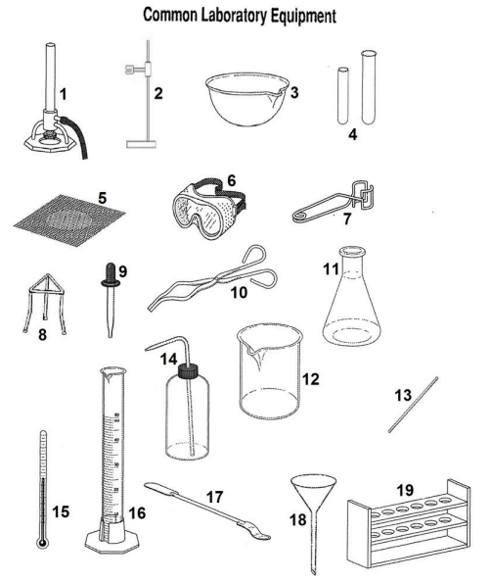

A certain group of S.1 students was tasked to carry out different experiments but they were confused of the appropriate apparatus to use in those experiments. From the above figure, suggest the name of the apparatus learners need to carry out these experiments below;

1. In measuring volumes of different solutions. (***03marks)***

....................................................................................................................................................................................................................................................................................................................................................................................................................................................................................

1. In heating different compounds/substances (***06marks)***

........................................................................................................................................................................................................................................................................................................................................................................................................................................................................................................................................................................................................................................................................................................................................................................................................................................................................................................................................................................

1. In qualitative analysis (***03marks)***

............................................................. ...............................................................

........................................................... ..............................................................

............................................................ ................................................................

4. Objects we use in everyday life are made from materials, which are either plastics, ceramics, metals, wood, glass etc.

(a) State **two useful** properties of plastics, which make them popular*.* ***(02marks)*** ................................................................................................................................................................................................................................................................................................................................................................................................................................................................................................................................................................................................................................................

(b) Plastic waste management is a challenge in our communities today. Poor disposal of plastics as shown in the picture below is a big threat to human health around Uganda.

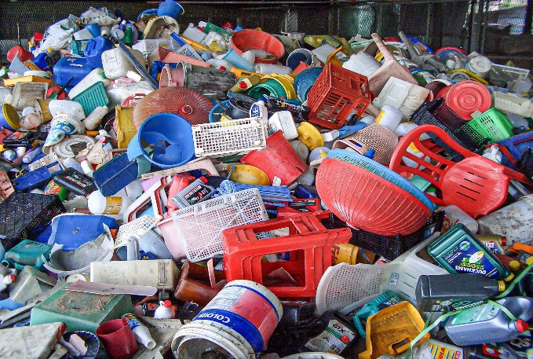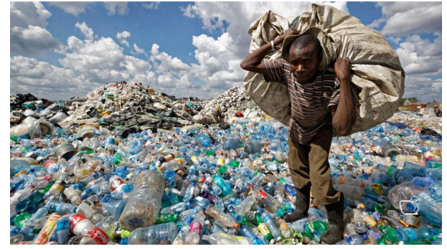

What **threats** do plastics pose to the environment and man? ***(05marks)***

................................................................................................................................................................................................................................................................................................................................................................................................................................................................................................................................................................................................................................................................................................................................................................................................................................................................................................................................................................................................................................................................................................................................................................................................................................................

(c) Suggest **two possible solutions** to the threats plastics pose to the environment you have written in (a) above. ***(02 marks)***

........................................................................................................................................................................................................................................................................................................................................................................................................................................................................................................................................................................................................................

5. Elements are used in manufacturing materials you use in daily life including building, roofing materials, medicine, jewelry, currency, kitchen equipment and many others.

1. Identify any five elements you know and give their uses in daily life. ***(05marks)***

........................................................................................................................................................................................................................................................................................................................................................................................................................................................................................................................................................................................................................................................................................................................................................................................................................................................................................................................................................................

1. Compounds are substances made up of two or more elements chemically combined together. Identify any four compounds you know in the environment and state their uses. ...........................................................................................................................................................................................................................................................................................................................................................................................................................................................................................................................................................................................................................................................................................................................................................................................................................................................................................................................................................................................................................(***04marks)***

**SECTION B: Note, this is a Scenario type question on Changes ( 20 MARKS)**

The Ministry of Agriculture established a demonstration fish pond in your area. New species of fish were introduced in the fish pond. However the weather changes and all the water got frozen , and all the fish died. When the weather normalized, only the water was restored but the fish species could not be recovered.

**Support material**

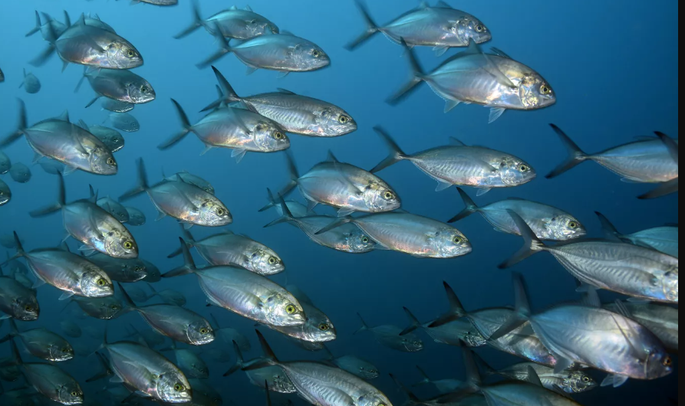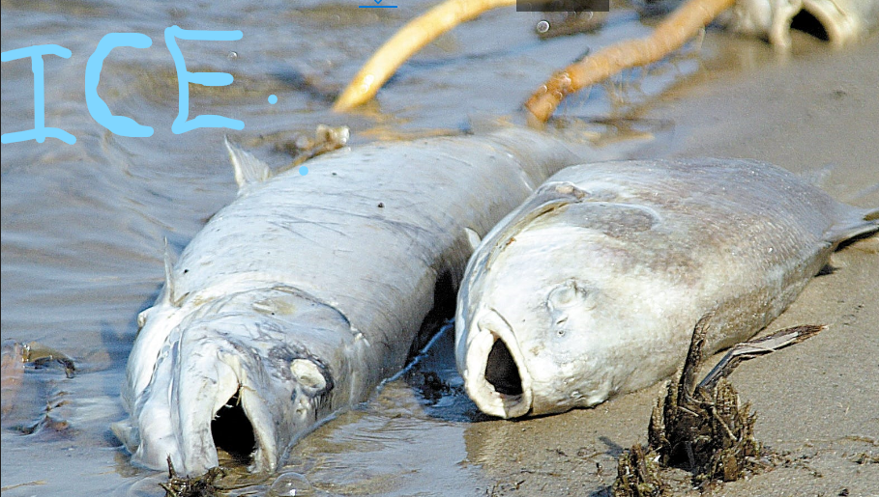

**TASK:**

Write a ***report*** explaining changes that took place in the water and fish species and how the repeating of the problem can be avoided, additionally stating any three differences between permanent and temporary changes.

**END**